**2024 Masters**

**ISD 3**

**Prototype**

Rahny Day

**Interaction**

there was a significant consideration for cognitive overload. My focus was a simplistic framework so participants could fully leverage resources and not have to worry about understanding jargon specific to transracial and trans international adoption. Consideration was also given to various stakeholders because they would mention a support system for adopters or as ambassadors to spread the word of the workshops.

**Intention**

As with any intervention, the focus is to have all resources be accessible. This does not just extend to those with physical, cognitive obstacles, but having resources be easy to obtain via location or consideration of time factors.

**Introspection**

As a transracial adoptee, my experience has been paramount and my approach and construction of this. This topic is very challenging and not only its construction, the complexity of all the moving parts, but the emotional load that is present it challenges, viewpoint, and the way that current lifestyles are lived, and also the compilation of all lived experiences.

**Click the photos or links below to the prototype**

[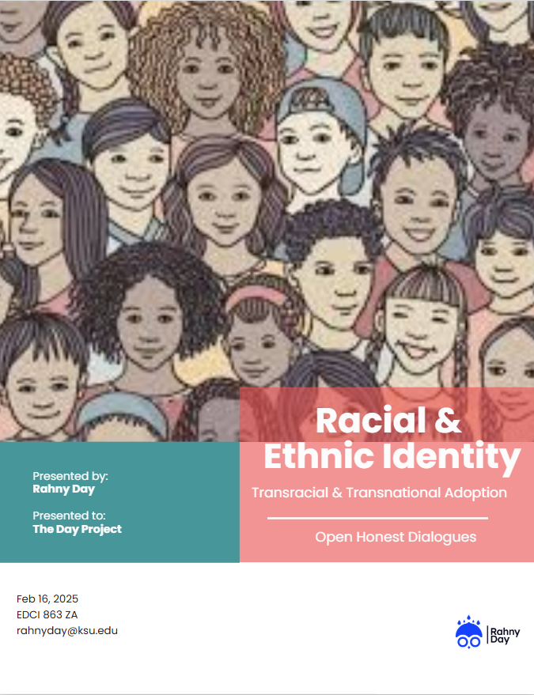](https://drive.google.com/drive/folders/1uzuA7g-pTZCydoQjpRY2Huj1pMUnUrv9?usp=drive_link)

[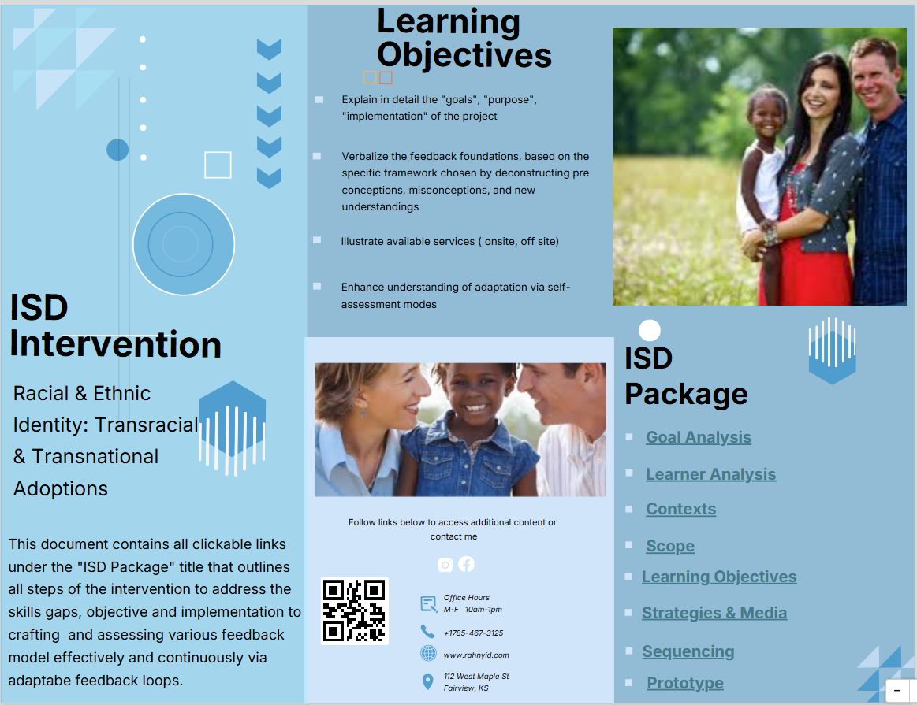](https://infograph.venngage.com/pl/H9IUSt4hfQ)

* [**Race & Ethnic Identity for Transracial & Transnational Adoption Intervention Package**](https://infograph.venngage.com/pl/H9IUSt4hfQ)
* [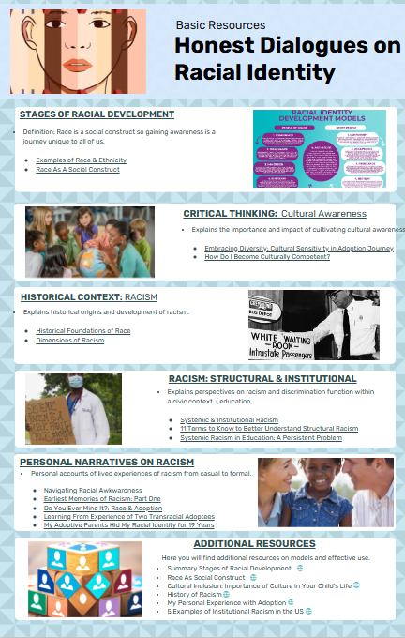](https://infograph.venngage.com/pl/DnqDV9zr0n4)
* [**Race & Ethnic Identity Educational Concept Infographic**](https://infograph.venngage.com/pl/DnqDV9zr0n4)